**Question 1.** Given an HMM with parameters specified below, calculate P(Rain2 | Umbr1, Umbr2), i.e. that it’s rainy on day 2 after observing umbrellas on day 1 and day 2.

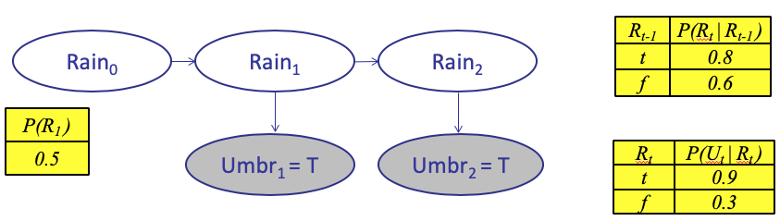

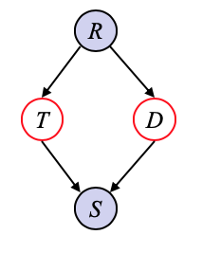

**Question 2:** Given the Bayes Net shown to the right, use D-separation to answer the following questions about conditional independence:

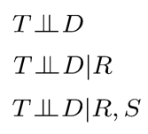

A)

B)

C)

